Exhibition EX – IGS
XII. international glass sympozium IGS 2015
March 30, 2016 at 6:30 p.m. – Opening reception
March 31 – June 19, 2016 – Exhibition in Glass Art Centre, Sazava
April 1, 2016 at 10:00 a.m. – Press konference Mediální centrum ORBIS, Czech Tourism, Praha

Exhibition curator: Mgr. Milan Hlaves, Ph.D.
Exhibition architect: MgA. Adam Simecek
Exhibition organizer: CESTY SKLA, o.p.s. – WAYS OF GLASS
Official patronage: Governor of Central Bohemia Region Ing. Milos Petera.

Main partners:
- Foundation of Joseph Viewegh Glassworks Frantisek
- Central Bohemia Region
- Museum of Decorative Arts in Prague
- City Sazava
- City Novy Bor
- Povodí Vltavy, State Enterprise
- Glass Museum Novy Bor

Partners:
- PRECIOSA Lighting Kamenicky Senov
- AJETO GROUP Lindava & Novy Bor
- KOLEKTIV ATELIERS Novy Bor
- PACINEK GLASSWORKS Lindava and Kunratice u Cvikova
- GLASSWORK SLAVIA Novy Bor
- TGK Skalice u Ceske Lipy
- AVE CLARA Polevsko
- CRYSTALEX CZ Novy Bor
- GLASS SCHOOL Novy Bor
- Posazavi o.p.s.

Media partners:
- Sklář a Keramik
- RADIO 1
- CzechTourism
- Kulturio.cz
- KAM po Česku
- PROTIŠEDI
- Kulturissimo.cz
- Design Cabinet CZ
- DesignMagazin
- Místní kultura
- Informuji.cz

Exhibition EX – IGS

A unique contemporary world glass exhibition which is taking place in an authentic environment of a renovated cultural monument – the Glassworks Frantisek in Sazava – is one of the largest exhibitions in terms of size and number of artists, coming from over twenty countries.
Around 200 artworks, created by the hands of the world’s greatest glass artists during the 12th International Glass Symposium last year in Novy Bor, are displayed. The artworks of the 12th international glass symposium are glass sculptures, installations and conceptual projects celebrating the magical beauty of glass in all its forms. Technological experiments are among the new approaches in the authors fine art and industrial design.
At the Sazava Glass Art Centre, the EX – IGS exhibition connecting the permanent exhibition of the IGS collections from the years 1989 – 2006 with artworks created at IGS 2015. A coming together of the selected authors works arises over time. Such interconnection of both permanent exhibition and new installation will show a unique example of the evolution of the creative process and the artistic concept of the contemporary art.
The exhibition will be accompanied by a wide variety of events, including presentations, guided tours and demonstrations of glass techniques.

International Glass Symposium IGS

The International Glass Symposium IGS was first held in 1982. The Glassworks Crystalex in Novy Bor invited artists and designers from all over the world to realize their ideas with the assistance of local glass makers. Since then, once every three years, the top glass artists get together and work in the hot and cold workshops together with the glass makers, before amateur and professional public, to demonstrate their art. Over years, hundreds of artists participated. The International Glass Symposium became a world unique and prestigious event, a meeting place and a symbol of creativity and of new possibilities in the world of glass.

The town of Novy Bor took charge of the organization of the last three symposiums. „Such original bond of self management and cosponsors brought new clients to the manufacturers, and new businesses and jobs were created. Indeed, that benefits everyone.“ said the president of the IGS and mayor of Novy Bor, Jaromir Dvorak.

Organizer: CESTY SKLA, o.p.s. – WAYS OF GLASS (public benefit organization)

The company was founded to provide public services, aiming to support the development and promotion of the contemporary glass art. The company operates in a former glassworks Frantisek in Sazava. Since 2010, the factory is listed as a Cultural Heritage.
It was foundation of Joseph Viewegh Glassworks Frantisek who worked to rescue this monument. They renovated it with a 130 million Czech Crowns grant given by the Integrated Operational Program.

The contact for further information:
Martina Kulhavá, director of CESTY SKLA, o.p.s.
tel.: 736 521 859, e-mail: kulhava@cestyskla.cz, www.cestyskla.cz

Photo – Glass Art Centre, Glassworks Frantisek in Sazava (photocredit: CESTYSKLA, o.p.s.)
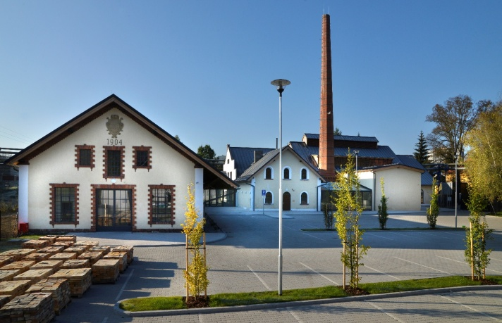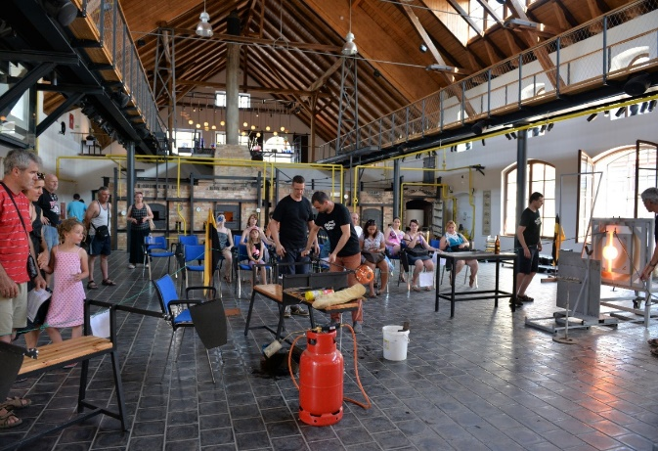
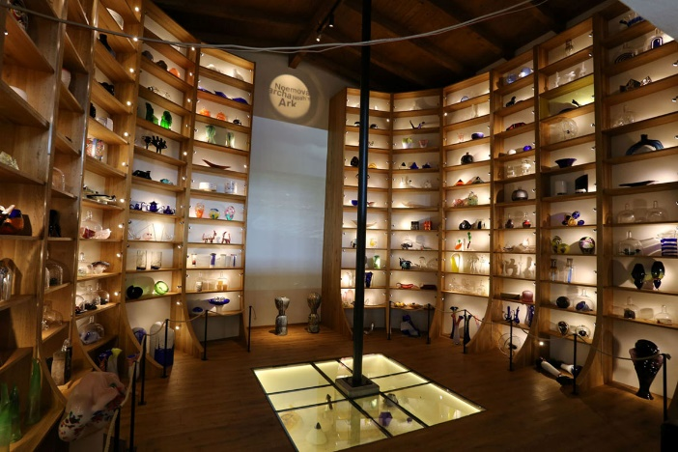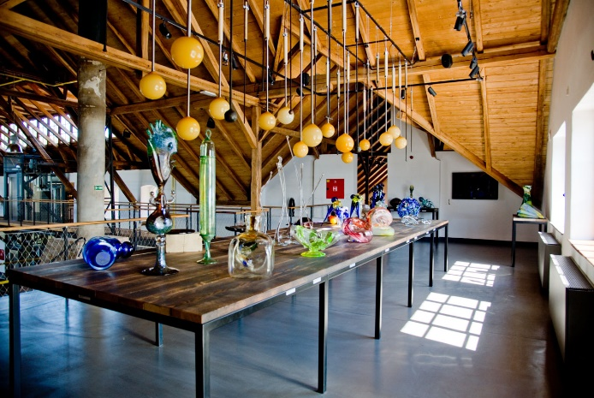

Photo of exhibition IGS in Glass museum Npvy Bor (photocredit: Gabriel Urbanek)
